DK1004 Service Manual

Cautions:
• High voltage inside player is very dangerous; please make sure that power cord is cut off from power supply before opening the cover when servicing!
•There are many high-voltage components inside player, pay attention to all the warning and instruction marked on the player when serving to prevent electric shock.
•Replace only with the same or equivalent type of components according to the specifications. Do not attempt to change the parameter of the components without permission in case of causing dangers.
- DK1004 Schematic Diagram
Introduction of the Function Achievement
IC PT2322 for 5.1CH volume and level adjustment, and perform the standby and mute function well
CPU utilizes IC AT89C2051
IC RC4558 (or F4558) to magnify small signals and active LPF
Power IC AFT9843J for L and R Channel power amplification
Power IC TDA8947J for SR, SL, C channel power amplification SW channel power amplification uses AFT9843J to constitute BTL form
Display state uses LED digital tube, which range from 0~16
All functions are remote controlled
Build in Cyber Logic function
Round transformer; bridge-style and full-wave rectifier circuit
Satellite speaker body and subwoofer speaker body are all MDF wood structure, with PVC rubber attached to the surface
Subwoofer speaker adopts 6.5 inch special bass unit for double magnet and aluminum coil.
Adopt unified flat heat radiator, with uniformly punched rectangle radiating roles above and fit on rear board directly to well radiate

2. Detailed Circuit Diagram Specifications:
1. Power & amplifier board
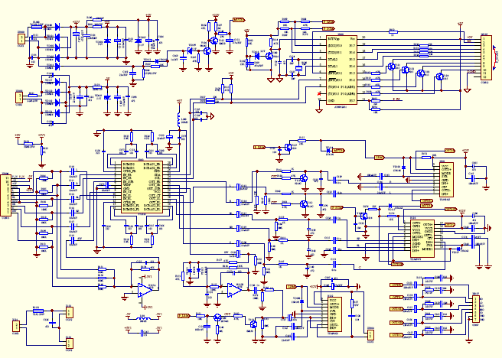
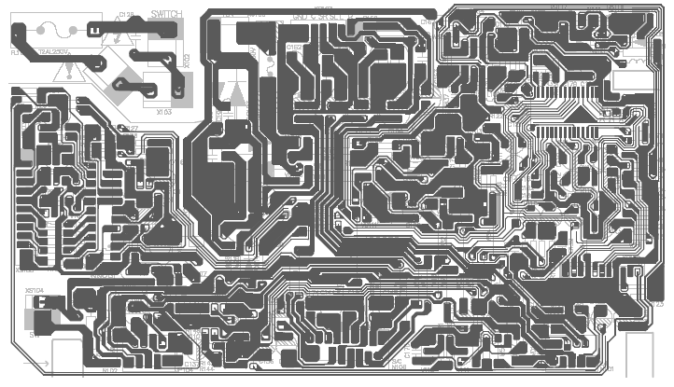
Caution:
As serving power amplifier board, make sure IC is stuck to the big heat radiation board and not crooked when assembling power IC N101, N102, N106. Add splitting (with silicon) between the screw and power IC. When fixing power IC N101, N102, N106 screws, you must add an insulating washer for insulation between screw and power IC. Use a multimeter to examine the insulation. Otherwise, the IC will be damaged by short-circuit.
- Input Board
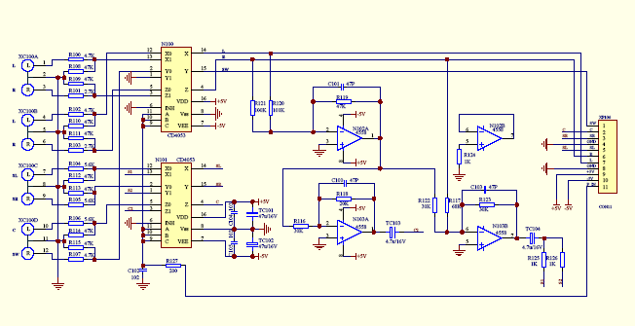
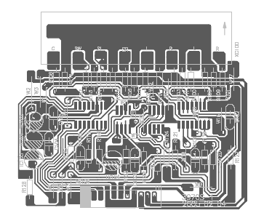
- Output Board Part
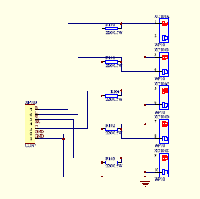

- Panel Board
